Faculty of Business, IT, and Management

HACK2200 Hacking and Exploits

Lab 5: Maintaining Access - Answer File

**Syed Adil Ahmed Altaf Hussain**

**100841799**

**NOTE: There is a 5 marks penalty per extra screenshot and a 5 marks penalty per extra username/password combination.**

**Part 1 – Gain Access**

Insert Screenshot#1 Here (10 Marks)

Insert Screenshot#2 Here (20 Marks)

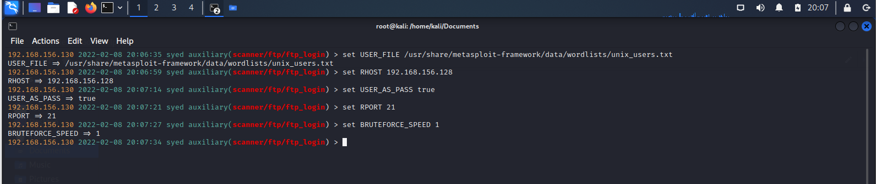

Question 1: What username/password are you using for this lab from the list you have obtained from the scanner? (20 Marks)

Username: **vagrant**

Password: **vagrant**

**Part 2 – Maintain Access**

Insert Screenshot#3 Here (25 Marks)

Insert Screenshot#4 Here (25 Marks)

